English Translation (not perfect but close enough)
The Car Guide> News> Electrical>
From coast to coast with a 100% electric Audi E-tron:
A few days after being one of the first Canadians to take possession of an Audi e-tron, Harvey Soicher took the challenge of crossing the country from British Columbia to Newfoundland. While we spoke with this traveler, he was about to leave Montreal before briefly staying in Quebec, and then on the road to New Brunswick. • See also: The autonomy of the Audi e-tron is rather disappointing • Also read: Tesla Model X 2019: Electrons for offspring Passing through Montreal, he took advantage of it to have a bite to eat at the famous Orange Julep on the Décarie Expressway, in addition to visiting the Montebello region. If he makes this journey, it is because it is a dream that he and his wife had in common. Unfortunately, she passed away due to a terrible cancer last year. In an interview, he said that this landmark event made him realize how short life is. "I live the journey with her spiritually even though she is no longer with me physically," he added. On July 2, Mr. Soicher left his Vancouver home to go to Victoria first. At that time, he had two options: To get to the Atlantic Ocean, then have his vehicle transported home by train or return home by driving through the United States. Noting the immense pleasure he feels so far and the welcome of the people he meets on the road, he chose the second option.
Not just any vehicle

This man is about to cross Canada from west to east, but not driving any vehicle. Indeed, the e-tron quattro is the first all-electric vehicle marketed by Audi.

Of course, Mr. Soicher was first attracted by the Tesla brand and its Model X. But its base price is more than $ 25,000 that of the e-tron. What's more, you cannot install a roof rack on the Model X, which was a major disadvantage for this man who practices a multitude of sports.

While driving before a Volkswagen Touareg TDI and Audi Q5, the change of scenery is not without bounds. With a battery of 95 kWh, the e-tron quattro can usually travel up to 400 kilometers with a single recharge. To this end, this traveler explained to us that depending on various factors, including temperature, altitude, wind force and direction and type of road, this autonomy could vary between 360 and 400 kilometers.

To aid in finding charging stations Mr. Soicher immediately downloaded the Plugshare app on his smartphone. He told us that it greatly facilitated the planning of his itinerary as it shows all the charging stations in each area on his trip. At the time of the interview, he mentioned that he had to pay only $ 75 to recharge since the beginning of his journey. He said some of the hotels he was staying in were offering free charging and that was also the case for Audi dealerships with their level 3 chargers.

He wanted to make this dream come true at this moment because he is aware that "recharging infrastructure will improve over the next few years and it will be easier and easier". The challenge surrounding this project is an important attraction for him.
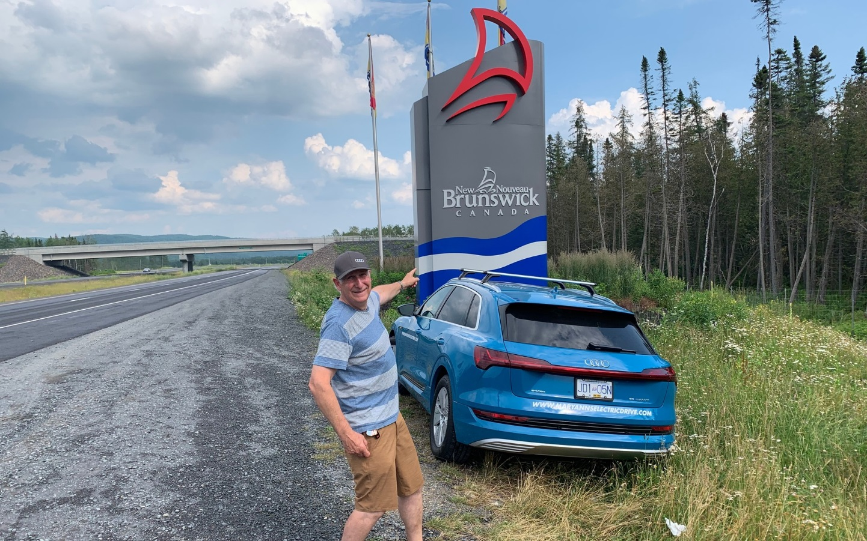
For a good cause
Born in Montreal but currently residing in British Columbia, Harvey Soicher began this journey to raise money for the VGH foundation for Dr. Christopher Honey who cared for his late wife. At the turn of the millennium, she suffered a brain aneurysm and escaped without any sequelae. On a goal of $ 50,000, he raised more than $ 12,000 at the time of writing. To donate:
http://support.vghfoundation.ca/site/TR?team_id=1720&fr_id=1110&pg=team

